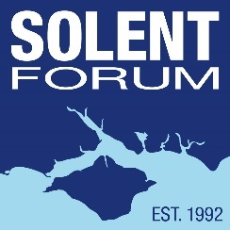

Solent Forum

Professor Mike Clark Award 2024: Application Form

Deadline 17 May 2024.

Please submit the completed application form and return to: solentforum@hants.gov.uk.

Contact Details:

Student Name:

Address:

Mobile:

University Attended:

Course/Research Title:

Project Title:

Student’s Email Address:

Supervisor’s Name:

Supervisor’s Email:

Date Submitted:

Summary:
Please summarise your project in approx. 100 words.

Rationale
Please explain why you have chosen to undertake this research (max 200 words)

Aim and Objectives
Please state the overall aim and objectives of the project (max 200 words).

Methodology and Timescale

Please state how you intend to undertake the research and the project timescale. Indicate any aspects of the methodology for which you may require external assistance (max 300 words).
Start Date: Estimated Completion Date:

Anticipated Outcome of the Research
Please describe what tangible benefits to the Solent will result from your research (max 200 words).

Estimated Costs and Amount Applied For (maximum £300)
Please estimate the project costs. Please note that costs should be for core project work and associated expenses, not for printing and binding or hardware/software purchases or similar.

Are you applying for other grants/funding for this project? If yes please specify.

Would the project go ahead in its proposed format if the Professor Mike Clark Award were not available?

Thank you for your application.

